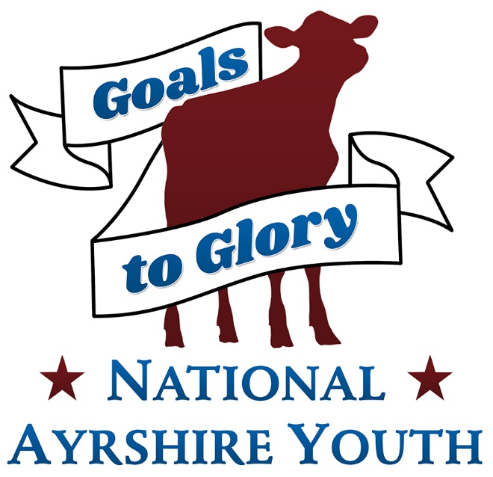
Ambassador Program

Rules

1. Candidates must be junior members in good standing with the Ayrshire Breeders’ Association.
2. Candidates must be between the ages of 16-21 by December 31st of the current convention year.
3. Candidates must enter on an official entry blank, signed by their parent or guardian by June 10th. Applications can be emailed to info@usayrshire.com
4. Candidates (or their state association, if applicable) are responsible for their own expenses in conjunction with the contest.
5. Candidates will be judged by a committee on general intelligence, speaking ability, knowledge and experience of the Ayrshire breed as well as goals and plans for promotion.
6. Candidates must sign a National Ayrshire Ambassador Code of Conduct form.
7. The Ambassador and Delegates shall conform to all the rules and regulations outlined in the Code of Conduct.
8. The Ambassador and Delegates must provide their own chaperone for events, particularly if they are under 18 years of age.
9. The Ambassadors’ responsibilities include being at the National Convention (both the year they are selected and the following year for the selection of a new ambassador). The Ambassador is encouraged to attend as many National Junior Shows as possible, but is required to be present for at least one show. National Junior Shows are held at National Ayrshire Summer Spectacular (NY), Midwest National Ayrshire Show (WI), Eastern States National Show (Big E, MA), Mid-Atlantic National Show (AADS, PA), International Show (WDE, WI) and Southern National Show (NAILE, KY).
10. The Delegate(s) are responsible for fulfilling the responsibilities in the absence of the ambassador, if they are unable to attend an Ayrshire function. Communication between the parties will need to occur on a semi-regular basis.
11. Expenses incurred by the National Ambassador during the commission of the ambassador duties will be the responsibility of the individual and/or their family. The National Ambassador will receive $500 (from the National Ayrshire Youth Fund to help with travel expenses, disbursed as follows: $250 will be paid after they attend one National Junior Show, with the balance being paid following the National Convention where their commission concludes. The National Ambassador is permitted to receive sponsorships from individuals and/or state associations to assist with travel and expenses.
12. All applicants are expected to assist with youth activities at the National Convention, including the fun auction, or as requested by the committee members. Contestants are expected to be appropriately attired throughout the convention. Attire should be formal for awards banquets, business attire for interviews and business casual for other activities. Jeans are appropriate for farm tours.
13. The winner of the contest will be named National Ayrshire Ambassador and up to 3 other individuals will be named delegates.
National Ayrshire Ambassador Contest Application Form

Application deadline: June 10th – Applications can be emailed to info@usayrshire.com

Name: __________________________ DOB:__________ Age: _____
Address: ____________________________________________________
Telephone: ___________________________
Parent or Guardian Name: ______________________________________
Parent or Guardian Address: ____________________________________
School and/or current employment: _______________________________
Name and address of local paper(s): ______________________________
Farm Name: ______________________________
Number of registered Ayrshires the applicant owns or leases:
Cows________ Heifers________ Calves________

Hobbies, Interests & Activities:

Special Honors:

National Ambassador Essay Questions
These questions should be typed on a separate piece of paper with each question restated at the top of the page.

1. Explain your involvement with the Ayrshire Breed and your farm.
(Outline your affiliation with Ayrshires, involvement with your herd and your involvement with the breed)

2. Explain how you have benefited from your experience with Ayrshires.

3. Explain why you would like to be the National Ayrshire Ambassador and how you can help promote the breed.

4. What are your future plans?

5. What should the Ayrshire breed emphasize to stay competitive in the industry today?

NATIONAL AYRSHIRE AMBASSADOR CODE OF CONDUCT FORM

1. The National Ayrshire Ambassador shall represent the Ayrshire Breeders’ Association at all times when on official public appearances that have been approved by the Ayrshire Youth Committee, and shall abide by the following guidelines:

a. The Ambassador shall promote the Ayrshire Breeders’ Association, the Ayrshire cow and her product.
b. They shall uphold the highest ideals of professionalism, dress, poise and personality.
c. They shall not consume any alcoholic beverages while representing the Ayrshire Breeders’ Association at any Ayrshire function.

2. The selection of the Ayrshire Ambassador is limited to single candidates, never married and never had a child. A candidate must be between the ages of 16-21 by December 31 of the current convention year. In the event the National Ayrshire Ambassador marries during the year of their duty, they shall be expected to forfeit their title.

3. The National Ayrshire Ambassador attire shall be accessorial if the occasion suggests. The National Ayrshire Ambassador shall avoid informal attire as much as possible on official occasions of official representations.

If, for any reason, the National Ayrshire Ambassador cannot uphold the above standards, they will be expected to forfeit their title upon notification by the Youth Committee.

I have read the Code of Conduct for the Ayrshire Ambassador Contest and promise that if I am selected as the National Ayrshire Ambassador, I will abide by the Code of Conduct with the understanding that any violation may result in the forfeit of my title.

Applicant’s Signature_________________________________ Date _______________

I have read this application and certify that, to the best of my knowledge, the information is correct.

Parent’s Signature ___________________________________ Date _______________

